NAME: K NAVYA
REG NUMBER: 192371022
COURSE: JAVA CSA0910

Pattern Program 1: Right-Angled Triangle of Stars
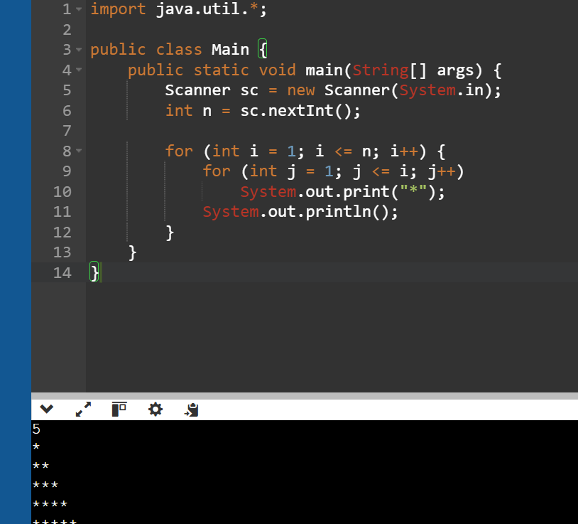
�� Pattern Program 2: Number Pyramid
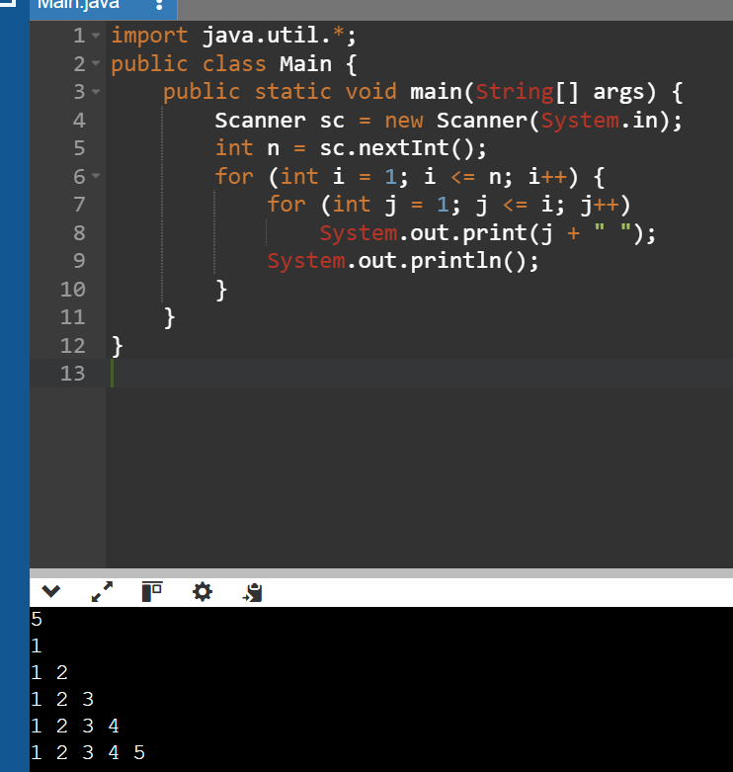

3. Hollow Square Pattern

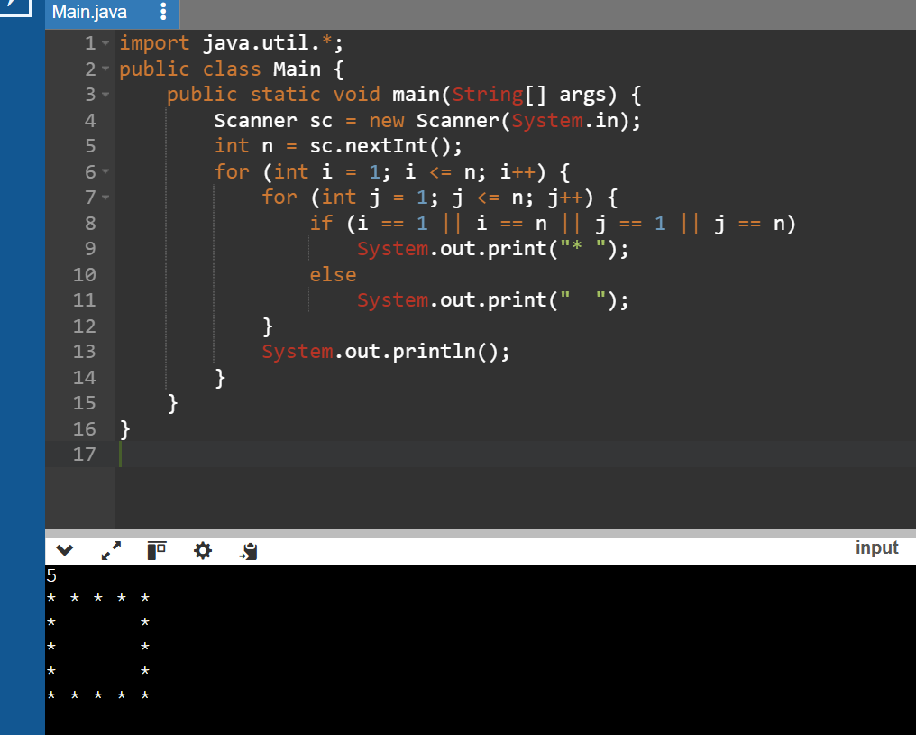

4. Number Right-Angled Triangle
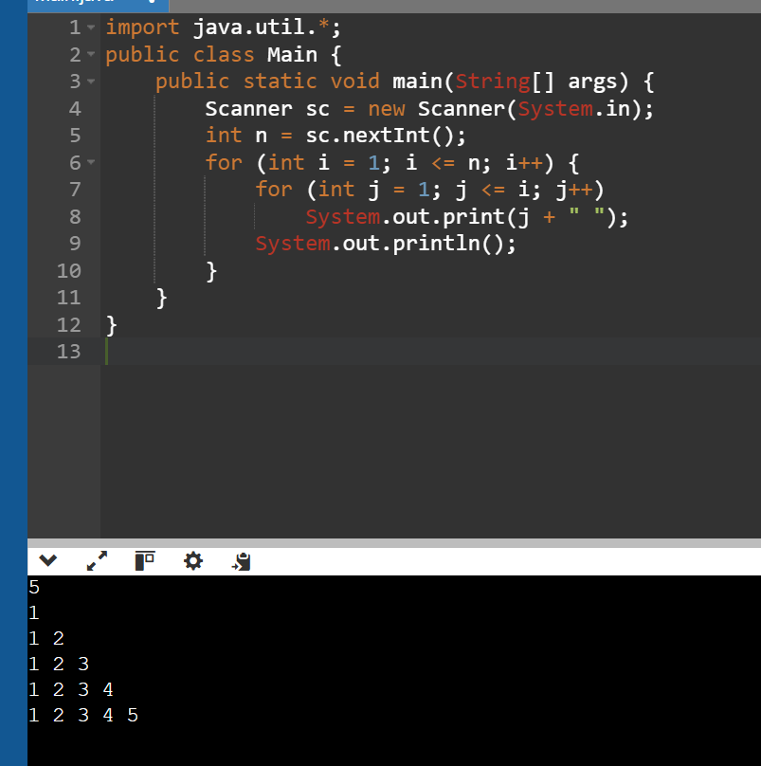

5. Alphabet Triangle Pattern
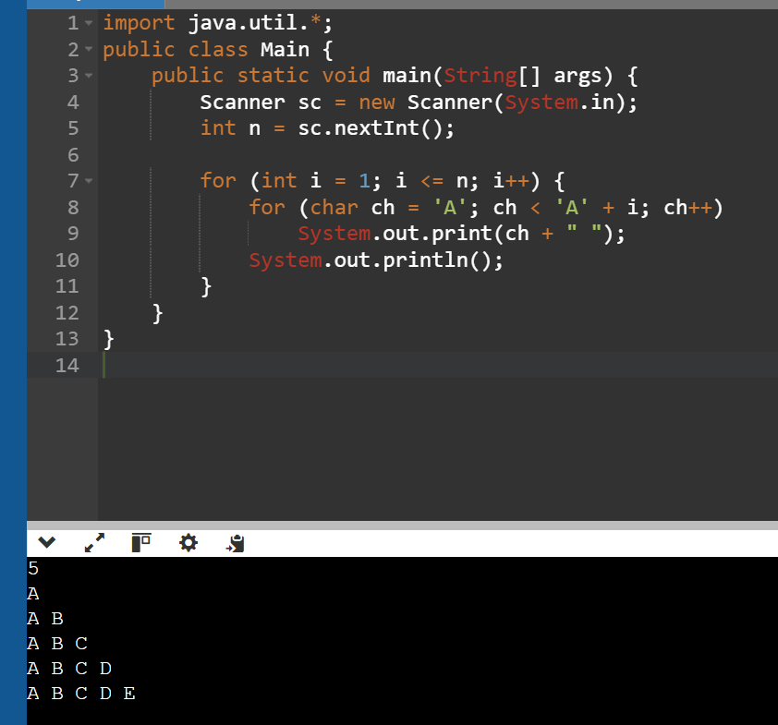

6. Diamond Star Pattern
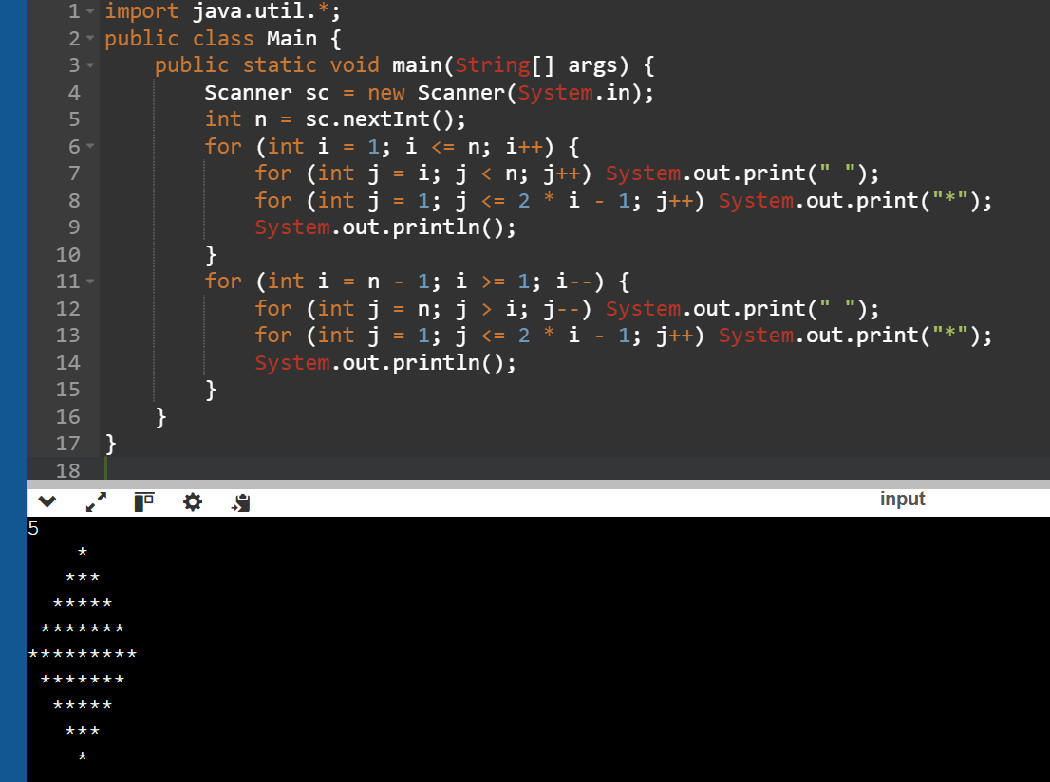

7. Floyd’s Triangle
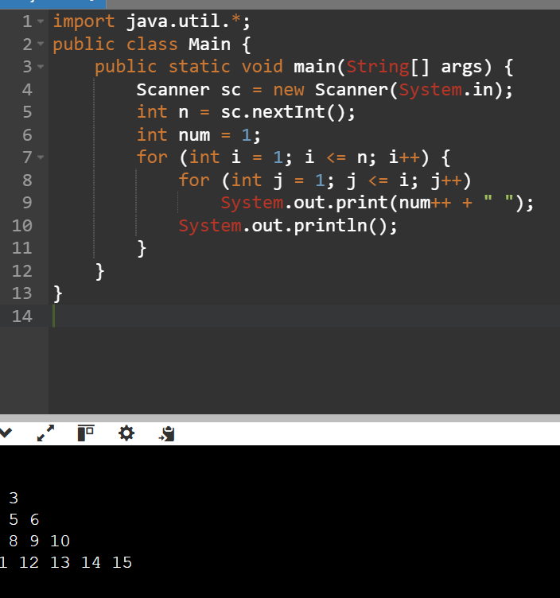

8. Right-Aligned Star Triangle
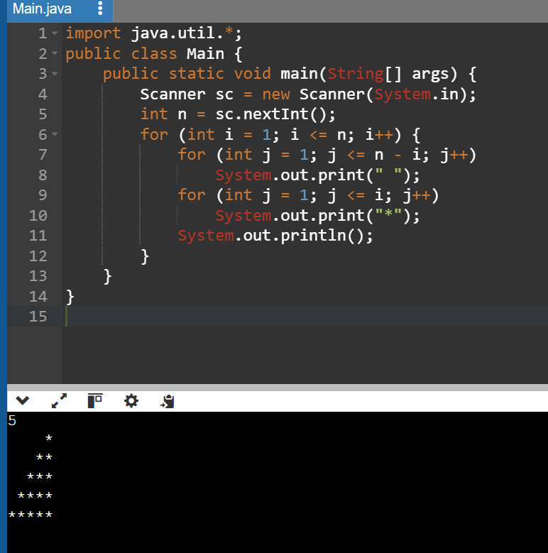

9. Inverted Number Triangle
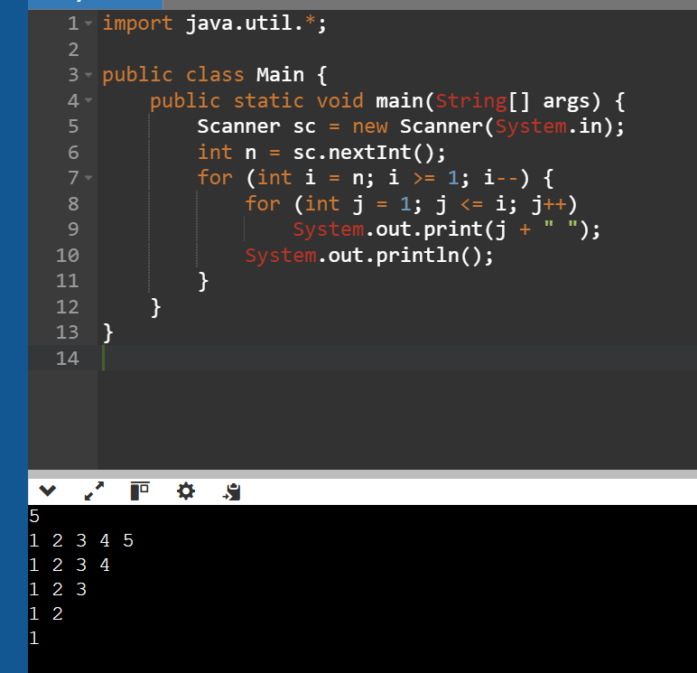
10. Binary Number Triangle
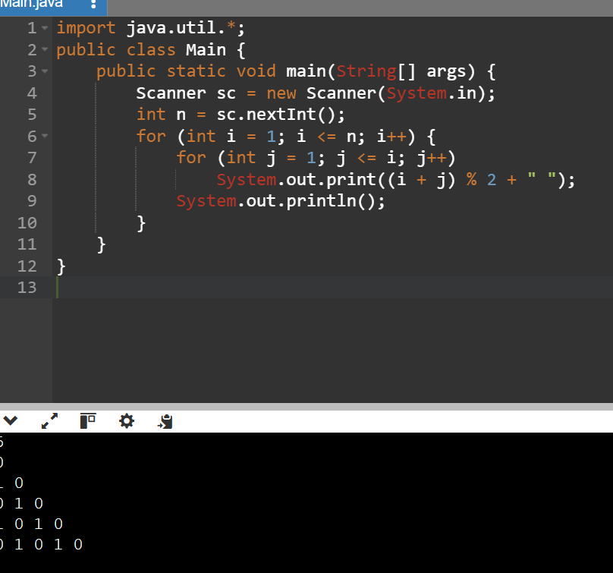

11. Half Diamond Star Pattern
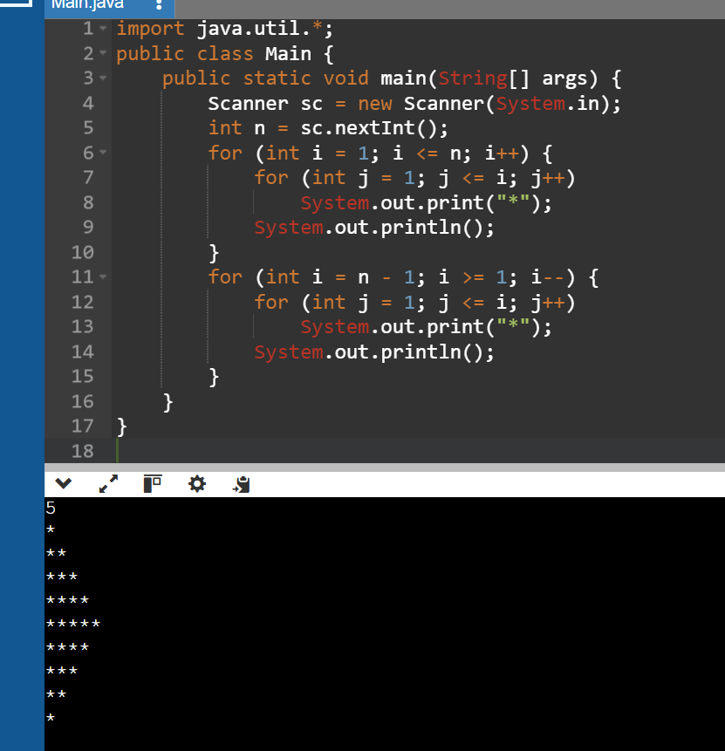

12. Hollow Right-Angled Triangle
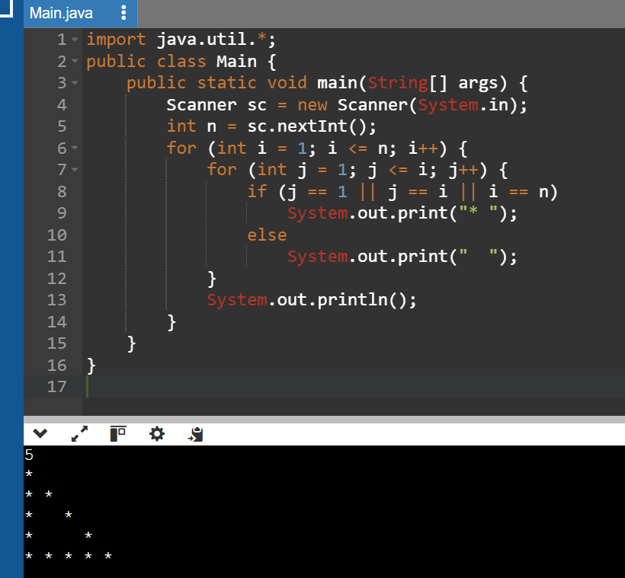

13. Reverse Pyramid of Stars
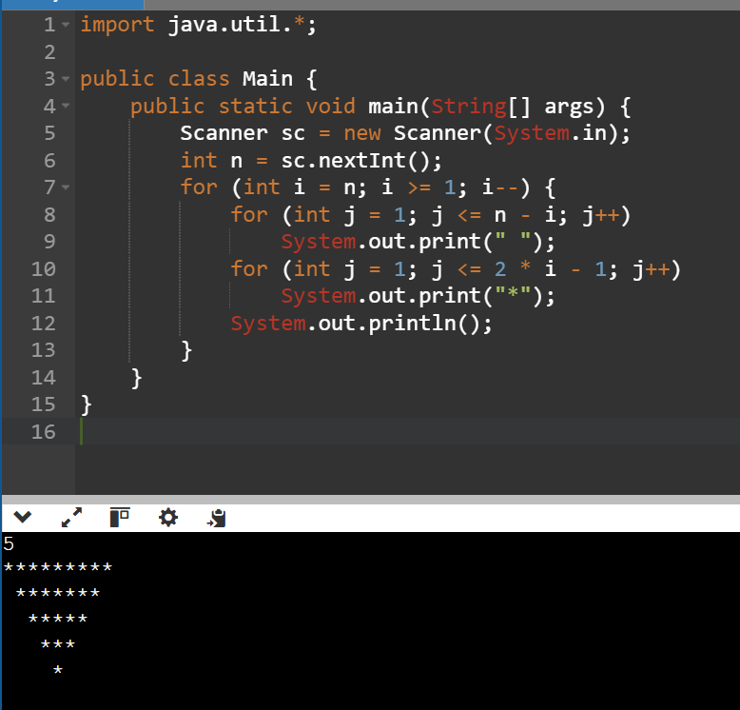
14. Continuous Characters Triangle
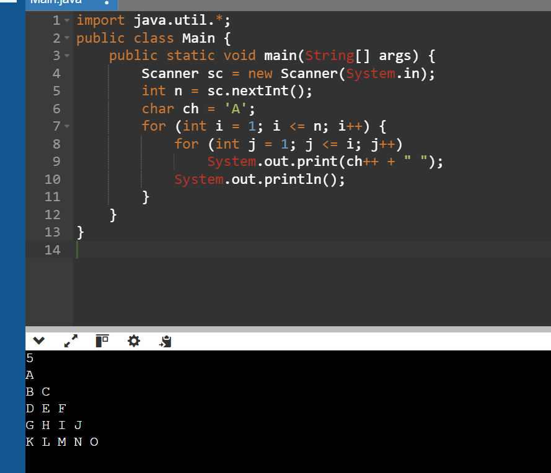

15. Right-Angled Triangle with Even Numbers
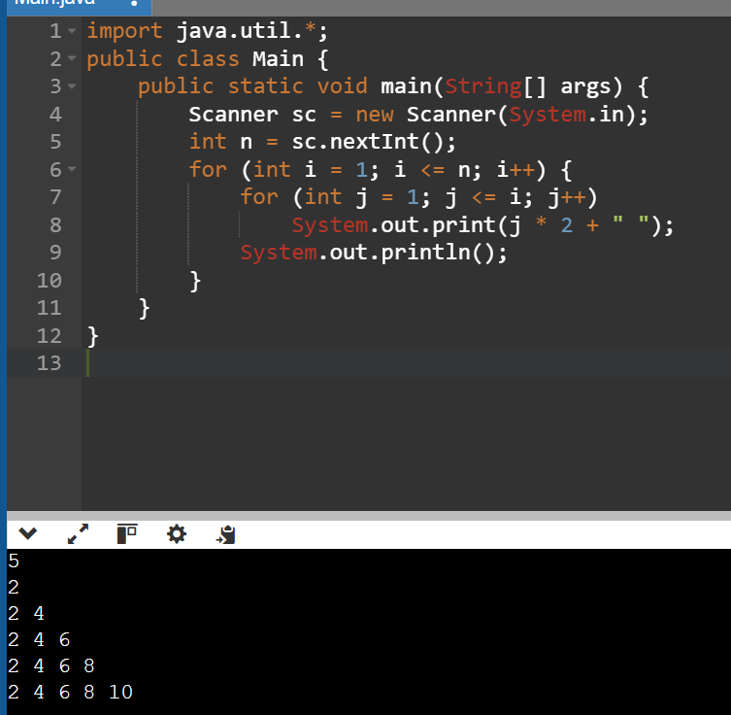
16. Triangle of Odd Numbers
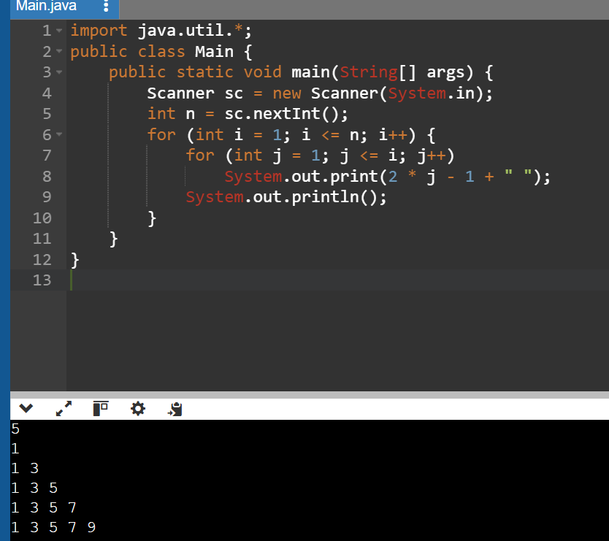

17. Hollow Pyramid Pattern
